Name: | ___________________________________________________ |  |  | Date: ___________
 | Year 9 Mathematics  Test 5, 2015  Topics – Statistics |  |  | 55  = %
Total Time: | 60 minutes
Total Reading: | 5 minutes
Total Working: | 55 minutes
Weighting: | ______% of the year.
SECTION 1: CALCULATOR FREE
Time: | 23 minutes | Marks for Section 1: | 21
Reading: | 2 minutes | Equipment Allowed: | Nil
Working: | 21 minutes

1. | [2 marks: ½ each]
categorical data range continuous data discrete data
mean skewed symmetrical mode
 | Complete the following using words from the list above.
a) | The number of goals scored by each team in one round of a netball competition is an example of  ____________________.
b) | If a statistical graph is not skewed it is said to be ____________________.
c) | The height of each student in your class is an example of ___________________.
d) | The difference between the highest and lowest score is the ___________________.

2. | [2 marks]
 | Explain why your weight is considered to be continuous data rather than discrete even though you record it as 52 kg, 55 kg, etc.

3. | [5 mark: 2, 1, 1, 1]
 | The sale of ice creams from the school canteen was recorded for the past 15 days.
 | 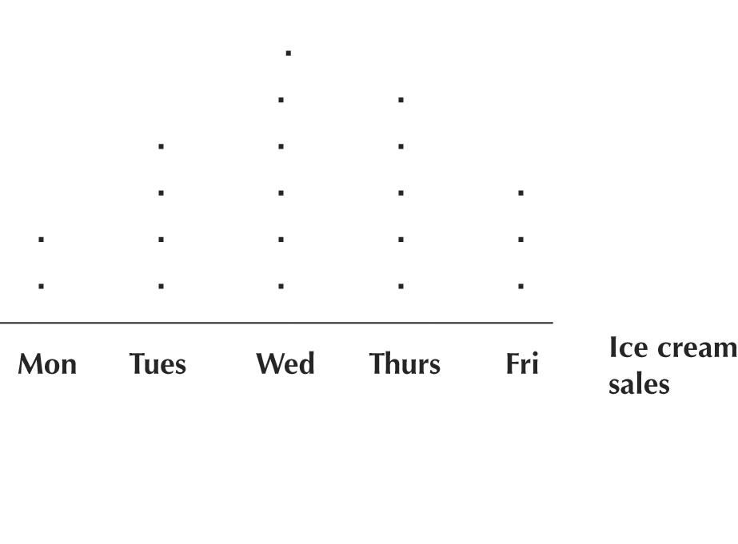
a) | Display this information as a column graph.
 | 
b) | When did the sale of ice creams peak?
c) | What was the average number of ice creams?
d) | What day do you think was the coldest? Give reasons for your answer.

4. | [1 mark]
 | Abbey scores the following scores in 6 hands of a card game.
 | 200, 180, 160, 140, 100 and 40.
 | Find the median of her scores.

5. | [2 marks]
 | Five friends earn the following marks on a quiz out of 10 marks:
 | 5, 5, 6, 9 and 10.
 | Find the mean of their marks.

6. | [1 mark]
 | Ellie plays eight games of netball and scores the following number of goals:
 | 8, 3, 6, 7, 12, 9 and 14.
 | What is the range of her scores?

7. | [1 mark]
 | Taylah records the number of minutes of exercise she does each day over two weeks.
 | Mon | Tue | Wed | Thur | Fri | Sat | Sun
Week 1 | 20 | 45 | 30 | 20 | 60 | 45 | 60
Week 2 | 45 | 20 | 45 | 30 | 20 | 45 | 35

 | Find the mode of her times.

8. | [1 mark]
 | Which histogram could not be described as being bimodal?
A | 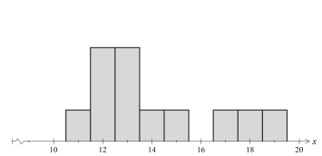 | B | 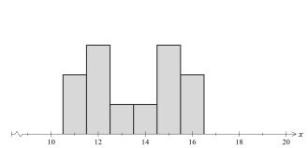
C | 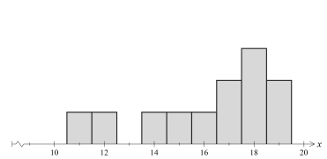 | D | 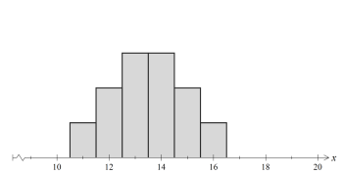

9. | [3 marks: 1, 1, 1]
Mitchell's scores in 20 shots at a dartboard.

Stem | Leaf
0 | 3 | 5 | 7 | 9 | 9
1 | 0 | 4 | 7 | 8 | 9 | 9
2 | 2 | 5 | 6 | 6 | 6 | 6 | 9 | 9
3
4
5
6 | 0

a) | What is the mode of the scores?
b) | Which score could be described as an outlier?
c) | What effect would it have on the mean if the outlier were not included in the data? (You do not have to calculate the mean to answer this question.)

9. | [3 marks: 1, 1, 1]
 | Two students show different histograms for the same set of data.
 | 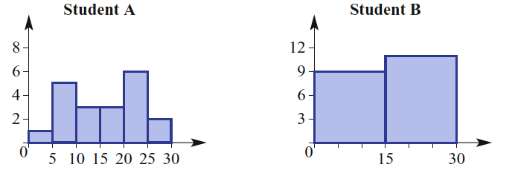
a) | Which histogram is more useful in helping to analyse the data? Justify your decision.
b) | What would you advise student B to do differently when constructing the histogram?

~ END OF TEST SECTION 1 ~
Name: | ___________________________________________________ |  |  | Date: ___________
SECTION 2: CALCULATOR ASSUMED
Time: | 37 minutes | Marks for Section 2: | 34
Reading: | 3 minutes | Equipment Allowed: | ½ page notes (A4 one side), Scientific calculator
Working: | 34 minutes

10. | [3 marks: 1, 1, 1]
 | Data was collected for a footy tipping competition one week, and the results are summarised below:
 | 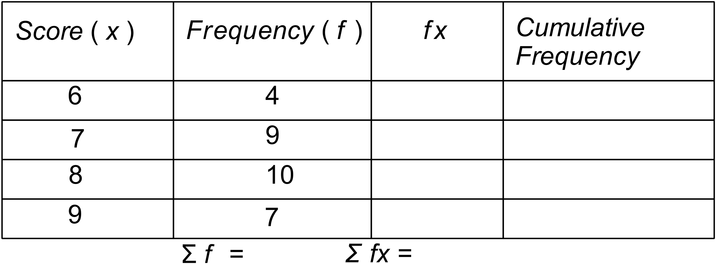
a) | What is the mode of the scores?
b) | What is the median of the scores?
c) | What is the mean of the scores (correct to one decimal place)?

11. | [1 mark]
Heather records the ages of her 16 young cousins in the dot plot.
 |  |  |  | o
 |  | o |  | o
 | o | o | o | o | o
o | o | o | o | o | o | o | o
4 | 5 | 6 | 7 | 8 | 9 | 10 | 11
She realises that she has left out a cousin who is 7.
Which statistical measures (mean, median, mode, range) will change when she includes the extra score?

12. | [2 marks]
 | The results on the same test for two classes are shown in the tables.
Ms Hypatia
Score | Frequency
20 | 0
21 | 1
22 | 8
23 | 7
24 | 7
25 | 6
Mr Kepler
Score | Frequency
20 | 3
21 | 6
22 | 7
23 | 8
24 | 3
25 | 2

 | Explain why comparing the mode for each class would not give an accurate comparison of the two class’s performances on the test.

13. | [4 marks: 2, 1, 1]
Consider the following stem-and-leaf plot:

STEM LEAF
0 6, 7
1 4, 7
2 1, 5, 3, 3, 5, 3
3 7, 4, 1, 5
4 6, 2

a) | Redraw the stem-and-leaf plot as an ordered stem-and-leaf plot.
b) | Calculate the median
c) | Calculate the mean.

14. | [8 marks: 2, 3, 1, 2]
 | The following frequency table shows the distance thrown, in metres, by the students in the javelin competition at the Annual Athletics Carnival.

Distance (m) | Frequency
0−<10 | 4
10−<20 | 12
20−<30 | 24
30−<40 | 9
40−<50 | 1

a) | Calculate an estimate for the mean distance thrown by the competitors.
b) | Draw a histogram to represent the data set.
 | 
c) | Use the shape of the histogram to describe the data set.
d) | 15 students were disqualified without recording a valid distance. Would it be reasonable to include these results? If you did record them what effect would they have on the mean and the median value?

15. | [11 marks: 5, 4, 1, 1]
The following lists are of heights, in cm, of 30 Year 9 students from each of NSW and Victoria recorded in 2011.
NSW students:
164 160 167 164 176 156 188 164 166 174 179 167
142 148 175 126 155 150 173 179 146 182 152 160
170 172 162 174 182 152

Victoria students:
167 164 166 186 167 165 182 161 177 157 161 162
165 165 172 166 167 178 160 160 167 174 175 164
167 175 159 168 162 174

a) | Draw a back-to-back stem-and-leaf plot of the data.
b) | Find the mean and median height for the students from each State. Give answers correct to one decimal place if necessary.
c) | What conclusions can you draw from the stem plot and the statistics calculated regarding the height of Year 9 students from NSW compared to those from Victoria?
d) | The mean height of Year 9 students in 2011 was reported as 165.38 cm and the median as 167.0 cm. How do you think the samples above compare to these values? Give some detail in your answer.

16. | [5 marks]
Compare the following data sets using as many statistics as you can.

Set A: 1, 2, 4, 7, 11, 12, 14, 16 Set B: 3, 5, 6, 7, 10, 11, 12, 13

~ END OF TEST SECTION 2 ~

